Exhibition
The Prize Bag: Double Lives of Architecture
Architecture Prize of the Province of Styria 2025
Opening: February 25, 2026, 7 p.m. at HDA, Mariahilferstraße 2, 8020 Graz
Exhibition: February 26 – May 15, 2026, Tu–Su 11 a.m.–5 p.m.
Guided exhibition tours: Saturdays 3 p.m., Sundays 11 a.m. and on request
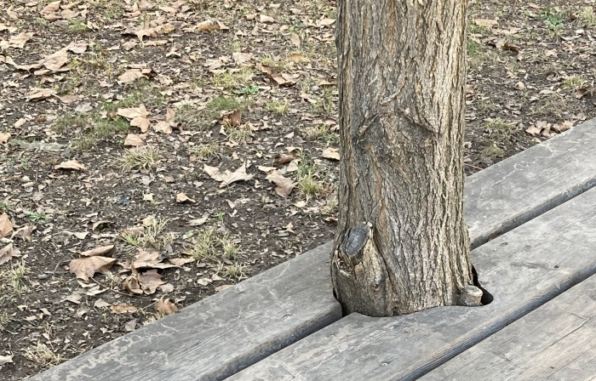
Detail, Salon Stolz © Oral Göktaş
The Prize Bag: Double Lives of Architecture exhibition was developed within the framework of the Architecture Prize of the Province of Styria. Curated by Sevince Bayrak and Oral Göktaş of the Istanbul-based studio SO? architecture and ideas, the exhibition and accompanying publication propose shifting our understanding of architectural prizes—seeing them as instruments for inquiry rather than final judgments. Moving beyond the award submissions, the exhibition asks what lies behind images of buildings where stories of life steadily accumulate. What happens between concept and completion, between drawing and everyday use? What remains invisible, yet decisive for lived reality?
Drawing on the architects’ previous curatorial work, Carrier Bag Theory of Architecture, buildings are understood as containers of stories—of collaboration, unpredictability, and transformation. Through visits to 14 shortlisted projects across Styria, in-depth conversation with international architectural theorist Hilde Heynen, and extensive material shared by the architectural offices who were shortlisted, Double Lives of Architecture reveals the messy, unpredictable, and deeply human processes behind built form. By assembling photographs, drawings, collages, construction documents, notes, and crisis moments, the exhibition traces the “double lives” of architecture: the tension between image and use, between idealized narratives and the realities of construction and adaptation over time. Rather than celebrating architecture as a finished object, The Prize Bag keeps the discussion open—inviting visitors to look closer and reconsider architecture’s multifaceted nature.
If a building is understood as a container—a carrier bag that holds layers of transformation, unpredictability, and messiness, as proposed in the Carrier Bag Theory of Architecture—then an architectural prize can become more than a mechanism of selection. It can become a tool for deep exploration, shifting attention away from the circulation of images toward the essence of architecture itself.
The Prize Bag: Double Lives of Architecture emerged from this premise within the context of the Architecture Prize of the Province of Styria. Instead of treating the prize as a final destination or a label for the “best” project, the curators approached it as a catalyst—one that generates questions from the collective body of 14 shortlisted works. What can be learned when these projects are read together? What stories unfold beyond the polished photographs submitted for the architectural prize?
To move beyond representation, the curators initiated a three-day journey across Styria, visiting the shortlisted projects together with architects, clients, users, and institutions. At the same time, they invited the offices to share additional material: construction photographs, rejected details, technical drawings, notes, crisis documentation, budget information, and reflections rarely made public. The process, which involved several in-depth conversations, including with the international architectural theorist Hilde Heynen, provided the backbone for the exhibition.
The “double lives” of architecture unfold between image and use, intention and reality, concept and crisis. Buildings appear not as static outcomes, but as evolving entities—beginning on paper, shaped through negotiation on-site, and continuously redefined through daily life. From single-family homes and kindergartens to hospitals, care facilities, schools, and public infrastructure, the exhibition traces how architecture operates across scales, ages, and social conditions.
Recurring themes surface throughout the exhibition: care and comfort, education and learning environments, the role of public space, cycles of material and nature, the challenges of building within existing structures, and the invisible labor behind “simple” architectural gestures.
Rather than offering conclusions, The Prize Bag: Double Lives of Architecture assembles stories that build upon one another. In doing so, it keeps architecture open: as a shared cultural practice embedded in everyday life, steadily shaped by those who inhabit it.

Projects in the exhibition
Prize winner: Salon Stolz | Architektursalon and su.n -spaceunit network
Special Recognition: City Hall Kapfenberg | .tmp architekten
Special Recognition: LFS Grottenhof Modernisation | ARGE LFS GRO: Caspar Wichert Architektur + OSNAP Open South North Architecture Practice
Special Recognition: School Campus Reininghaus | j-c-k Architekten
Special Recognition: treehouse | konstruktiv – Studio für Architektur
House of Biodiversity at Herberstein Wildlife Park | Pretterhofer Arquitectos / MVD Austria
House F | MALEK HERBST Architekten
Education Campus Zeltweg | ARGE: reitmayr architekten + balloon architekten
Multi-Generational Care Knittelfeld | Dietger Wissounig Architekten
Öblarn Parish Kindergarten | GMP Architektur
Elementary School Reininghaus, Graz | dreiplus Architekten
Expansion of Child and Youth Psychiatry LKH Graz II Süd | ARGE: NOW Architektur + Architekt DI Tinchon
PALLIATIVE CARE UNIT AT THE REGIONAL HOSPITAL SÜDWESTSTEIERMARK, SITE DEUTSCHLANDSBERG | INNOCAD architecture
Re:House – A Circular Building | Agency in Biosphere – Markus Jeschaunig
Head of Programme
Zerina Džubur

Curators
Sevince Bayrak & Oral Göktaş

The exhibition, publication, and accompanying program are supported by the Province of Styria, Department 9 – Culture, Europe, Sports and the ZT-Kammer (Regional Chamber of Chartered Engineering Consultants).
Programme
Opening
The Prize Bag: Double Lives of Architecture
Architecture Prize of the Province of Styria 2025
Date: February 25, 2026, 7 p.m.
Location: Haus der Architektur, Mariahilferstraße 2, 8020 Graz

Discussion and Book Presentation
The Prize Bag: Double Lives of Architecture
Architecture Yearbook Graz Styria 2025
Date: April 29, 2026, 7 p.m.
Location: Salon Stolz, Theodor-Körner-Straße 67, 8010 Graz
With, among others: Sevince Bayrak | SO? architecture and ideas,
Andreas Ruby, former curator of the Architecture Prize of the Province of Styria
The Architecture Yearbook Graz Styria 2025 is the sixth volume in this series published by the curator of the Architecture Prize of the Province of Styria. For this edition, Sevince Bayrak and Oral Göktaş from the Istanbul-based architecture firm SO? architecture and ideas present a multifaceted selection of buildings, deliberately shifting the gaze to look behind conventional images of architecture.
Moving away from flawless presentation and media-driven staging, they reflect on collective negotiation processes, moments of crisis on construction sites, revised budgets, subsequent adaptations, and the voices of users. They show architecture as part of our actual lived reality and take the Architecture Prize as an opportunity to make visible those complex processes of building that otherwise remain in the background.

Discussion and Live Radio Show
Pflegestützpunkt, Radio Helsinki
With: Andreas Salfellner, Andreas Mayer, and residents of the senior citizens' residence, among others.
Date: March 13, 2026, 11:00 a.m.
Location: Salon Stolz, Theodor-Körner-Straße 67, 8010 Graz

Further information is available on the HDA website:
https://hda-graz.at/en/programme/the-prize-bag-double-lives-of-architecture

Press photos can be found at the following link:
https://hda-graz.at/en/press-area-hda/press-information-the-prize-bag-double-lives-of-architecture-architecture-prize-of-the-province-of-styria-2025

Contact
Dipl.-Ing. Nelly Sanjta
Communications, Education & EU-Project Management
T: +43 316 32 35 00 16
E. sanjta@hda-graz.at

